Abdul Haseeb

20f-1066 | bse-6a

SMD

firebase assignment

**Home Screen**

# **XML Code**

*<?*xml version="1.0" encoding="utf-8"*?>*<androidx.constraintlayout.widget.ConstraintLayout xmlns:android="http://schemas.android.com/apk/res/android"  
 xmlns:app="http://schemas.android.com/apk/res-auto"  
 xmlns:tools="http://schemas.android.com/tools"  
 android:layout_width="match_parent"  
 android:layout_height="match_parent"  
 tools:context=".HomeScreen">  
  
 <ImageView  
 android:id="@+id/imageView"  
 android:layout_width="357dp"  
 android:layout_height="177dp"  
 android:layout_marginTop="36dp"  
 app:layout_constraintEnd_toEndOf="parent"  
 app:layout_constraintStart_toStartOf="parent"  
 app:layout_constraintTop_toTopOf="parent"  
 app:srcCompat="@drawable/flexlogo"  
 tools:ignore="ContentDescription,ImageContrastCheck" />  
  
 <Button  
 android:id="@+id/button"  
 android:layout_width="166dp"  
 android:layout_height="67dp"  
 android:layout_marginTop="48dp"  
 android:text="@string/add_record"  
 android:onClick="AddRecord"  
 app:layout_constraintEnd_toEndOf="parent"  
 app:layout_constraintHorizontal_bias="0.493"  
 app:layout_constraintStart_toStartOf="parent"  
 app:layout_constraintTop_toBottomOf="@+id/imageView" />  
  
 <Button  
 android:id="@+id/button2"  
 android:layout_width="166dp"  
 android:layout_height="67dp"  
 android:layout_marginTop="32dp"  
 android:text="@string/delete_record"  
 android:onClick="DeleteRecord"  
 app:layout_constraintEnd_toEndOf="parent"  
 app:layout_constraintHorizontal_bias="0.497"  
 app:layout_constraintStart_toStartOf="parent"  
 app:layout_constraintTop_toBottomOf="@+id/button"  
 tools:ignore="TextSizeCheck,TextSizeCheck" />  
  
 <Button  
 android:id="@+id/button3"  
 android:layout_width="166dp"  
 android:layout_height="67dp"  
 android:layout_marginTop="32dp"  
 android:text="@string/update_record"  
 android:onClick="UpdateRecord"  
 app:layout_constraintEnd_toEndOf="parent"  
 app:layout_constraintHorizontal_bias="0.502"  
 app:layout_constraintStart_toStartOf="parent"  
 app:layout_constraintTop_toBottomOf="@+id/button2"  
 tools:ignore="TextSizeCheck" />  
  
 <Button  
 android:id="@+id/button4"  
 android:layout_width="166dp"  
 android:layout_height="67dp"  
 android:text="@string/reports"  
 android:onClick="CheckReports"  
 app:layout_constraintBottom_toBottomOf="parent"  
 app:layout_constraintEnd_toEndOf="parent"  
 app:layout_constraintHorizontal_bias="0.502"  
 app:layout_constraintStart_toStartOf="parent"  
 app:layout_constraintTop_toBottomOf="@+id/button3"  
 app:layout_constraintVertical_bias="0.253" />  
</androidx.constraintlayout.widget.ConstraintLayout>

# **Java Code**

package com.example.firebaseassignment;  
  
import androidx.appcompat.app.AppCompatActivity;  
  
import android.content.Intent;  
import android.os.Bundle;  
import android.view.View;  
  
public class HomeScreen extends AppCompatActivity {  
  
 @Override  
 protected void onCreate(Bundle savedInstanceState) {  
 super.onCreate(savedInstanceState);  
 setContentView(R.layout.*activity_home_screen*);  
 }  
  
 public void AddRecord(View view) {  
 Intent intent = new Intent(this, AddRecord.class);  
 startActivity(intent);  
 }  
  
 public void DeleteRecord(View view)  
 {  
 Intent intent = new Intent(this, DeleteRecord.class);  
 startActivity(intent);  
 }  
  
 public void UpdateRecord(View view)  
 {  
 Intent intent = new Intent(this, UpdateRecord.class);  
 startActivity(intent);  
 }  
  
 public void CheckReports(View view)  
 {  
 Intent intent = new Intent(this, DisplayReports.class);  
 startActivity(intent);  
 }  
}

# **Output**

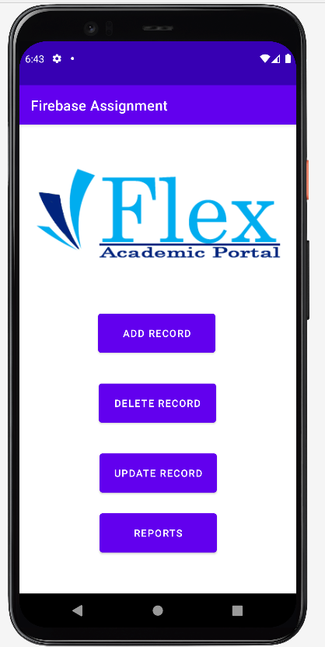

**Add Record**

# **XML Code**

*<?*xml version="1.0" encoding="utf-8"*?>*<androidx.constraintlayout.widget.ConstraintLayout xmlns:android="http://schemas.android.com/apk/res/android"  
 xmlns:app="http://schemas.android.com/apk/res-auto"  
 xmlns:tools="http://schemas.android.com/tools"  
 android:layout_width="match_parent"  
 android:layout_height="match_parent"  
 tools:context=".AddRecord">  
  
 <EditText  
 android:id="@+id/txtupdtatename"  
 android:layout_width="302dp"  
 android:layout_height="58dp"  
 android:layout_marginTop="52dp"  
 android:ems="10"  
 android:inputType="textPersonName"  
 android:hint="@string/enter_name"  
 app:layout_constraintEnd_toEndOf="parent"  
 app:layout_constraintHorizontal_bias="0.467"  
 app:layout_constraintStart_toStartOf="parent"  
 app:layout_constraintTop_toTopOf="parent"  
 tools:ignore="Autofill,LabelFor" />  
  
 <EditText  
 android:id="@+id/txtupdtatedept"  
 android:layout_width="299dp"  
 android:layout_height="54dp"  
 android:layout_marginTop="52dp"  
 android:ems="10"  
 android:inputType="textPersonName"  
 android:hint="@string/enter_department"  
 app:layout_constraintEnd_toEndOf="parent"  
 app:layout_constraintHorizontal_bias="0.482"  
 app:layout_constraintStart_toStartOf="parent"  
 app:layout_constraintTop_toBottomOf="@+id/txtupdtatename"  
 tools:ignore="Autofill,LabelFor" />  
  
 <EditText  
 android:id="@+id/txtupdtateregno"  
 android:layout_width="301dp"  
 android:layout_height="53dp"  
 android:layout_marginTop="44dp"  
 android:ems="10"  
 android:inputType="textPersonName"  
 android:hint="@string/enter_reg_no"  
 app:layout_constraintEnd_toEndOf="parent"  
 app:layout_constraintStart_toStartOf="parent"  
 app:layout_constraintTop_toBottomOf="@+id/txtupdtatedept"  
 tools:ignore="Autofill,LabelFor" />  
  
 <EditText  
 android:id="@+id/txtupdtatecgpa"  
 android:layout_width="306dp"  
 android:layout_height="57dp"  
 android:layout_marginTop="48dp"  
 android:ems="10"  
 android:hint="Enter Cgpa"  
 android:inputType="numberDecimal"  
 app:layout_constraintEnd_toEndOf="parent"  
 app:layout_constraintHorizontal_bias="0.514"  
 app:layout_constraintStart_toStartOf="parent"  
 app:layout_constraintTop_toBottomOf="@+id/txtupdtateregno"  
 tools:ignore="Autofill,LabelFor,SpeakableTextPresentCheck" />  
  
 <EditText  
 android:id="@+id/txtupdtateemail"  
 android:layout_width="304dp"  
 android:layout_height="59dp"  
 android:layout_marginTop="36dp"  
 android:ems="10"  
 android:hint="Enter Email"  
 android:inputType="textEmailAddress"  
 app:layout_constraintEnd_toEndOf="parent"  
 app:layout_constraintHorizontal_bias="0.523"  
 app:layout_constraintStart_toStartOf="parent"  
 app:layout_constraintTop_toBottomOf="@+id/txtupdtatecgpa"  
 tools:ignore="Autofill,LabelFor,SpeakableTextPresentCheck" />  
  
 <Button  
 android:id="@+id/btnupdateecord"  
 android:layout_width="135dp"  
 android:layout_height="62dp"  
 android:layout_marginBottom="72dp"  
 android:text="@string/save"  
 android:onClick="SaveRecord"  
 app:layout_constraintBottom_toBottomOf="parent"  
 app:layout_constraintEnd_toEndOf="parent"  
 app:layout_constraintStart_toStartOf="parent"  
 app:layout_constraintTop_toBottomOf="@+id/txtupdtateemail"  
 app:layout_constraintVertical_bias="0.766" />  
  
</androidx.constraintlayout.widget.ConstraintLayout>

# **Java Code**

package com.example.firebaseassignment;  
  
import androidx.appcompat.app.AppCompatActivity;  
  
import android.annotation.SuppressLint;  
import android.os.Bundle;  
import android.view.View;  
import android.widget.EditText;  
import android.widget.Toast;  
  
import com.google.firebase.database.DatabaseReference;  
import com.google.firebase.database.FirebaseDatabase;  
  
import java.util.HashMap;  
import java.util.Map;  
  
public class AddRecord extends AppCompatActivity {  
  
 FirebaseDatabase database;  
 DatabaseReference databaseReference;  
 EditText name, dept, reg_no, cgpa, email;  
 int i = 0;  
 @SuppressLint("MissingInflatedId")  
 @Override  
 protected void onCreate(Bundle savedInstanceState) {  
 super.onCreate(savedInstanceState);  
 setContentView(R.layout.*activity_add_record*);  
 name = findViewById(R.id.*txtupdtatename*);  
 dept = findViewById(R.id.*txtupdtatedept*);  
 reg_no = findViewById(R.id.*txtupdtateregno*);  
 cgpa = findViewById(R.id.*txtupdtatecgpa*);  
 email = findViewById(R.id.*txtupdtateemail*);  
  
 database = FirebaseDatabase.*getInstance*("https://fir-assignment-10086-default-rtdb.firebaseio.com/");  
 databaseReference = database.getReference("StudentRecord");  
 databaseReference.setValue("This is a database for student records");  
 }  
  
 public void SaveRecord(View view)  
 {  
 String[] students = {"Student 1", "Student 2", "Student 3", "Student 4", "Student 5"};  
 Map<String, Object> studentdata = new HashMap<>();  
 studentdata.put("Name", name.getText().toString());  
 studentdata.put("Dept", dept.getText().toString());  
 studentdata.put("Reg No", reg_no.getText().toString());  
 studentdata.put("CGPA", cgpa.getText().toString());  
 studentdata.put("Email", email.getText().toString());  
 databaseReference.child(students[i]).setValue(studentdata);  
 i++;  
 *// databaseReference.setValue(studentdata);* Toast.*makeText*(this, "Data saved successfully", Toast.*LENGTH_SHORT*).show();  
  
 }  
  
 public void UpdateRecord(View view)  
 {  
  
 }  
}

# **Outputs**

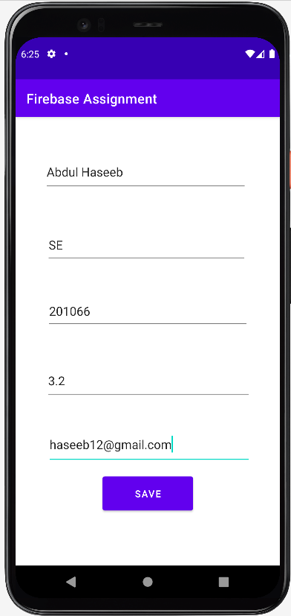

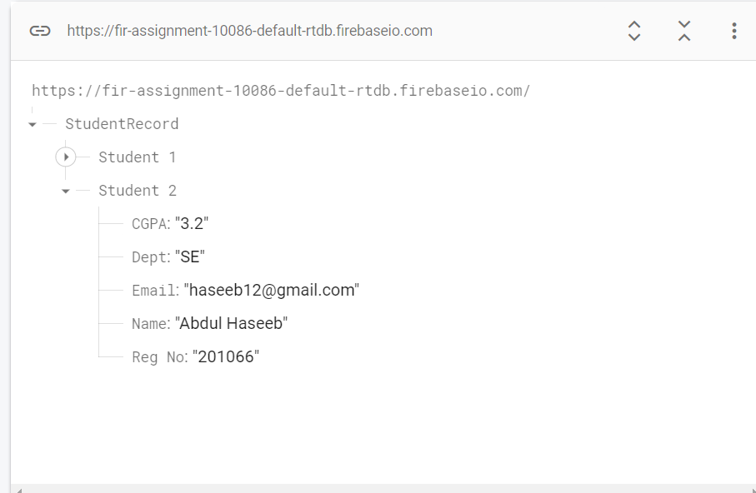

**Delete Record**

# **XML Code**

*<?*xml version="1.0" encoding="utf-8"*?>*<androidx.constraintlayout.widget.ConstraintLayout xmlns:android="http://schemas.android.com/apk/res/android"  
 xmlns:app="http://schemas.android.com/apk/res-auto"  
 xmlns:tools="http://schemas.android.com/tools"  
 android:layout_width="match_parent"  
 android:layout_height="match_parent"  
 tools:context=".DeleteRecord">  
  
 <EditText  
 android:id="@+id/txtdeleteregno"  
 android:layout_width="283dp"  
 android:layout_height="77dp"  
 android:layout_marginTop="120dp"  
 android:ems="10"  
 android:hint="Enter Reg No"  
 android:inputType="number"  
 app:layout_constraintEnd_toEndOf="parent"  
 app:layout_constraintStart_toStartOf="parent"  
 app:layout_constraintTop_toBottomOf="@+id/imageView2"  
 tools:ignore="Autofill,LabelFor,SpeakableTextPresentCheck" />  
  
 <ImageView  
 android:id="@+id/imageView2"  
 android:layout_width="wrap_content"  
 android:layout_height="wrap_content"  
 android:layout_marginTop="52dp"  
 app:layout_constraintEnd_toEndOf="parent"  
 app:layout_constraintHorizontal_bias="0.266"  
 app:layout_constraintStart_toStartOf="parent"  
 app:layout_constraintTop_toTopOf="parent"  
 app:srcCompat="@drawable/flexlogo"  
 tools:ignore="ContentDescription,ImageContrastCheck" />  
  
 <Button  
 android:id="@+id/btndeleterecord"  
 android:layout_width="117dp"  
 android:layout_height="60dp"  
 android:text="@string/delete"  
 android:onClick="DeleteRecord"  
 app:layout_constraintBottom_toBottomOf="parent"  
 app:layout_constraintEnd_toEndOf="parent"  
 app:layout_constraintStart_toStartOf="parent"  
 app:layout_constraintTop_toBottomOf="@+id/txtdeleteregno"  
 app:layout_constraintVertical_bias="0.134" />  
  
</androidx.constraintlayout.widget.ConstraintLayout>

# **Java Code**

package com.example.firebaseassignment;  
  
import androidx.annotation.NonNull;  
import androidx.appcompat.app.AppCompatActivity;  
  
import android.annotation.SuppressLint;  
import android.os.Bundle;  
import android.view.View;  
import android.widget.EditText;  
import android.widget.Toast;  
  
import com.google.firebase.database.DataSnapshot;  
import com.google.firebase.database.DatabaseError;  
import com.google.firebase.database.DatabaseReference;  
import com.google.firebase.database.FirebaseDatabase;  
import com.google.firebase.database.Query;  
import com.google.firebase.database.ValueEventListener;  
  
import java.util.ArrayList;  
  
public class DeleteRecord extends AppCompatActivity {  
  
 FirebaseDatabase database;  
 DatabaseReference databaseReference;  
 EditText reg_no;  
 String convert_regno;  
 ArrayList<String> arrayList;  
 @Override  
 protected void onCreate(Bundle savedInstanceState) {  
 super.onCreate(savedInstanceState);  
 setContentView(R.layout.*activity_delete_record*);  
 reg_no = findViewById(R.id.*txtdeleteregno*);  
 database = FirebaseDatabase.*getInstance*("https://fir-assignment-10086-default-rtdb.firebaseio.com/");  
 databaseReference = database.getReference("StudentRecord");  
   
 }  
  
 @SuppressLint("NotConstructor")  
 public void DeleteRecord(View view)  
 {  
 convert_regno = reg_no.getText().toString();  
 Query query = FirebaseDatabase.*getInstance*("https://fir-assignment-10086-default-rtdb.firebaseio.com/")  
 .getReference("StudentRecord")  
 .orderByChild("Reg No").equalTo(convert_regno);  
 query.addListenerForSingleValueEvent(new ValueEventListener() {  
 @Override  
 public void onDataChange(@NonNull DataSnapshot dataSnapshot) {  
 if (dataSnapshot.exists())  
 {  
 for (DataSnapshot snapshot : dataSnapshot.getChildren())  
 {  
 String key = snapshot.getKey();  
 FirebaseDatabase.*getInstance*("https://fir-assignment-10086-default-rtdb.firebaseio.com/")  
 .getReference("StudentRecord").child(key).child("Name").removeValue();  
 FirebaseDatabase.*getInstance*("https://fir-assignment-10086-default-rtdb.firebaseio.com/")  
 .getReference("StudentRecord").child(key).child("Dept").removeValue();  
 FirebaseDatabase.*getInstance*("https://fir-assignment-10086-default-rtdb.firebaseio.com/")  
 .getReference("StudentRecord").child(key).child("Reg No").removeValue();  
 FirebaseDatabase.*getInstance*("https://fir-assignment-10086-default-rtdb.firebaseio.com/")  
 .getReference("StudentRecord").child(key).child("CGPA").removeValue();  
 FirebaseDatabase.*getInstance*("https://fir-assignment-10086-default-rtdb.firebaseio.com/")  
 .getReference("StudentRecord").child(key).child("Email").removeValue();  
 }  
 reg_no.setText("");  
 Toast.*makeText*(DeleteRecord.this, "Record deleted", Toast.*LENGTH_SHORT*).show();  
  
 }  
 else  
 {  
 Toast.*makeText*(DeleteRecord.this, "Reg No not found", Toast.*LENGTH_SHORT*).show();  
 }  
 }  
  
 @Override  
 public void onCancelled(@NonNull DatabaseError error) {  
  
 }  
 });  
  
  
 }  
   
}

# **Outputs**

**Update Record**

# **XML Code**

## **UpdateRecord1.xml**

*<?*xml version="1.0" encoding="utf-8"*?>*<androidx.constraintlayout.widget.ConstraintLayout xmlns:android="http://schemas.android.com/apk/res/android"  
 xmlns:app="http://schemas.android.com/apk/res-auto"  
 xmlns:tools="http://schemas.android.com/tools"  
 android:layout_width="match_parent"  
 android:layout_height="match_parent"  
 tools:context=".UpdateRecord">  
  
 <ImageView  
 android:id="@+id/imageView3"  
 android:layout_width="wrap_content"  
 android:layout_height="wrap_content"  
 android:layout_marginTop="56dp"  
 app:layout_constraintEnd_toEndOf="parent"  
 app:layout_constraintStart_toStartOf="parent"  
 app:layout_constraintTop_toTopOf="parent"  
 app:srcCompat="@drawable/flexlogo"  
 tools:ignore="ContentDescription,ImageContrastCheck" />  
  
 <EditText  
 android:id="@+id/txtupdaterecord"  
 android:layout_width="248dp"  
 android:layout_height="55dp"  
 android:layout_marginTop="112dp"  
 android:ems="10"  
 android:inputType="number"  
 android:hint="Enter Reg No"  
 app:layout_constraintEnd_toEndOf="parent"  
 app:layout_constraintHorizontal_bias="0.496"  
 app:layout_constraintStart_toStartOf="parent"  
 app:layout_constraintTop_toBottomOf="@+id/imageView3"  
 tools:ignore="Autofill,LabelFor,SpeakableTextPresentCheck" />  
  
 <Button  
 android:id="@+id/btnupdate"  
 android:layout_width="139dp"  
 android:layout_height="63dp"  
 android:text="Update"  
 android:onClick="findRecord"  
 app:layout_constraintBottom_toBottomOf="parent"  
 app:layout_constraintEnd_toEndOf="parent"  
 app:layout_constraintStart_toStartOf="parent"  
 app:layout_constraintTop_toBottomOf="@+id/txtupdaterecord"  
 app:layout_constraintVertical_bias="0.156"  
 tools:ignore="HardcodedText" />  
</androidx.constraintlayout.widget.ConstraintLayout>

## **UpdateRecord2.xml**

*<?*xml version="1.0" encoding="utf-8"*?>*<androidx.constraintlayout.widget.ConstraintLayout xmlns:android="http://schemas.android.com/apk/res/android"  
 xmlns:app="http://schemas.android.com/apk/res-auto"  
 xmlns:tools="http://schemas.android.com/tools"  
 android:layout_width="match_parent"  
 android:layout_height="match_parent"  
 tools:context=".AddRecord">  
  
 <EditText  
 android:id="@+id/txtupdtatename"  
 android:layout_width="302dp"  
 android:layout_height="58dp"  
 android:layout_marginTop="52dp"  
 android:ems="10"  
 android:inputType="textPersonName"  
 android:hint="@string/enter_name"  
 app:layout_constraintEnd_toEndOf="parent"  
 app:layout_constraintHorizontal_bias="0.467"  
 app:layout_constraintStart_toStartOf="parent"  
 app:layout_constraintTop_toTopOf="parent"  
 tools:ignore="Autofill,LabelFor" />  
  
 <EditText  
 android:id="@+id/txtupdtatedept"  
 android:layout_width="299dp"  
 android:layout_height="54dp"  
 android:layout_marginTop="52dp"  
 android:ems="10"  
 android:inputType="textPersonName"  
 android:hint="@string/enter_department"  
 app:layout_constraintEnd_toEndOf="parent"  
 app:layout_constraintHorizontal_bias="0.482"  
 app:layout_constraintStart_toStartOf="parent"  
 app:layout_constraintTop_toBottomOf="@+id/txtupdtatename"  
 tools:ignore="Autofill,LabelFor" />  
  
 <EditText  
 android:id="@+id/txtupdtateregno"  
 android:layout_width="301dp"  
 android:layout_height="53dp"  
 android:layout_marginTop="44dp"  
 android:ems="10"  
 android:inputType="textPersonName"  
 android:hint="@string/enter_reg_no"  
 app:layout_constraintEnd_toEndOf="parent"  
 app:layout_constraintStart_toStartOf="parent"  
 app:layout_constraintTop_toBottomOf="@+id/txtupdtatedept"  
 tools:ignore="Autofill,LabelFor" />  
  
 <EditText  
 android:id="@+id/txtupdtatecgpa"  
 android:layout_width="306dp"  
 android:layout_height="57dp"  
 android:layout_marginTop="48dp"  
 android:ems="10"  
 android:hint="Enter Cgpa"  
 android:inputType="numberDecimal"  
 app:layout_constraintEnd_toEndOf="parent"  
 app:layout_constraintHorizontal_bias="0.514"  
 app:layout_constraintStart_toStartOf="parent"  
 app:layout_constraintTop_toBottomOf="@+id/txtupdtateregno"  
 tools:ignore="Autofill,LabelFor,SpeakableTextPresentCheck" />  
  
 <EditText  
 android:id="@+id/txtupdtateemail"  
 android:layout_width="304dp"  
 android:layout_height="59dp"  
 android:layout_marginTop="36dp"  
 android:ems="10"  
 android:hint="Enter Email"  
 android:inputType="textEmailAddress"  
 app:layout_constraintEnd_toEndOf="parent"  
 app:layout_constraintHorizontal_bias="0.523"  
 app:layout_constraintStart_toStartOf="parent"  
 app:layout_constraintTop_toBottomOf="@+id/txtupdtatecgpa"  
 tools:ignore="Autofill,LabelFor,SpeakableTextPresentCheck" />  
  
 <Button  
 android:id="@+id/btnupdateecord"  
 android:layout_width="157dp"  
 android:layout_height="61dp"  
 android:layout_marginBottom="72dp"  
 android:onClick="UpdateRecord"  
 android:text="Update Data"  
 app:layout_constraintBottom_toBottomOf="parent"  
 app:layout_constraintEnd_toEndOf="parent"  
 app:layout_constraintStart_toStartOf="parent"  
 app:layout_constraintTop_toBottomOf="@+id/txtupdtateemail"  
 app:layout_constraintVertical_bias="0.766" />  
  
</androidx.constraintlayout.widget.ConstraintLayout>

# **Java Code**

## **UpdateRecord1.java**

package com.example.firebaseassignment;  
  
import androidx.annotation.NonNull;  
import androidx.appcompat.app.AppCompatActivity;  
  
import android.content.Intent;  
import android.os.Bundle;  
import android.view.View;  
import android.widget.EditText;  
import android.widget.Toast;  
  
import com.google.firebase.database.DataSnapshot;  
import com.google.firebase.database.DatabaseError;  
import com.google.firebase.database.FirebaseDatabase;  
import com.google.firebase.database.Query;  
import com.google.firebase.database.ValueEventListener;  
  
public class UpdateRecord extends AppCompatActivity {  
  
 EditText reg_no;  
 String convert_regno;  
 @Override  
 protected void onCreate(Bundle savedInstanceState) {  
 super.onCreate(savedInstanceState);  
 setContentView(R.layout.*activity_update_record*);  
 reg_no = findViewById(R.id.*txtupdaterecord*);  
 }  
  
 public void findRecord(View view)  
 {  
 convert_regno = reg_no.getText().toString();  
 Query query= FirebaseDatabase.*getInstance*("https://fir-assignment-10086-default-rtdb.firebaseio.com/").getReference("StudentRecord").orderByChild("Reg No").equalTo(convert_regno);  
 query.addListenerForSingleValueEvent(new ValueEventListener() {  
 @Override  
 public void onDataChange(@NonNull DataSnapshot dataSnapshot) {  
 if (dataSnapshot.exists())  
 {  
 Toast.*makeText*(UpdateRecord.this, "Reg No found", Toast.*LENGTH_SHORT*).show();  
 Intent intent = new Intent(UpdateRecord.this, UpdateRecord2.class);  
 startActivity(intent);  
 }  
 else  
 {  
 Toast.*makeText*(UpdateRecord.this, "Reg No not found", Toast.*LENGTH_SHORT*).show();  
 }  
  
 }  
  
 @Override  
 public void onCancelled(@NonNull DatabaseError error) {  
 }  
 });  
  
  
 }  
}

## **UpdateRecord2.java**

package com.example.firebaseassignment;  
  
import androidx.annotation.NonNull;  
import androidx.appcompat.app.AppCompatActivity;  
  
import android.os.Bundle;  
import android.view.View;  
import android.widget.EditText;  
import android.widget.Toast;  
  
import com.google.firebase.database.DataSnapshot;  
import com.google.firebase.database.DatabaseError;  
import com.google.firebase.database.FirebaseDatabase;  
import com.google.firebase.database.Query;  
import com.google.firebase.database.ValueEventListener;  
  
public class UpdateRecord2 extends AppCompatActivity {  
  
 EditText name, dept, reg_no, cgpa, email;  
 String convert_name, convert_dept, convert_regno, convert_cgpa, convert_email;  
 @Override  
 protected void onCreate(Bundle savedInstanceState) {  
 super.onCreate(savedInstanceState);  
 setContentView(R.layout.*activity_update_record2*);  
 name = findViewById(R.id.*txtupdtatename*);  
 dept = findViewById(R.id.*txtupdtatedept*);  
 reg_no = findViewById(R.id.*txtupdtateregno*);  
 cgpa = findViewById(R.id.*txtupdtatecgpa*);  
 email = findViewById(R.id.*txtupdtateemail*);  
 }  
  
 public void UpdateRecord(View view)  
 {  
 convert_name = name.getText().toString();  
 convert_dept = dept.getText().toString();  
 convert_regno = reg_no.getText().toString();  
 convert_cgpa = cgpa.getText().toString();  
 convert_email = email.getText().toString();  
 Query query= FirebaseDatabase.*getInstance*("https://fir-assignment-10086-default-rtdb.firebaseio.com/").getReference("StudentRecord").orderByChild("Reg No").equalTo(convert_regno);  
 query.addValueEventListener(new ValueEventListener() {  
 @Override  
 public void onDataChange(@NonNull DataSnapshot dataSnapshot) {  
 if (dataSnapshot.exists()) {  
 for (DataSnapshot snapshot : dataSnapshot.getChildren()) {  
 String key = snapshot.getKey();  
 FirebaseDatabase.*getInstance*("https://fir-assignment-10086-default-rtdb.firebaseio.com/")  
 .getReference("StudentRecord").child(key).child("Name").setValue(convert_name);  
 FirebaseDatabase.*getInstance*("https://fir-assignment-10086-default-rtdb.firebaseio.com/")  
 .getReference("StudentRecord").child(key).child("Dept").setValue(convert_dept);  
 FirebaseDatabase.*getInstance*("https://fir-assignment-10086-default-rtdb.firebaseio.com/")  
 .getReference("StudentRecord").child(key).child("Reg No").setValue(convert_regno);  
 FirebaseDatabase.*getInstance*("https://fir-assignment-10086-default-rtdb.firebaseio.com/")  
 .getReference("StudentRecord").child(key).child("CGPA").setValue(convert_cgpa);  
 FirebaseDatabase.*getInstance*("https://fir-assignment-10086-default-rtdb.firebaseio.com/")  
 .getReference("StudentRecord").child(key).child("Email").setValue(convert_email);  
 }  
 name.setText("");  
 dept.setText("");  
 reg_no.setText("");  
 cgpa.setText("");  
 email.setText("");  
 Toast.*makeText*(UpdateRecord2.this, "Record updated successfully", Toast.*LENGTH_SHORT*).show();  
 }  
 else  
 {  
 Toast.*makeText*(UpdateRecord2.this, "Error", Toast.*LENGTH_SHORT*).show();  
 }  
 }  
  
 @Override  
 public void onCancelled(@NonNull DatabaseError error) {  
  
 }  
 });  
  
  
 }  
}

# **Outputs**

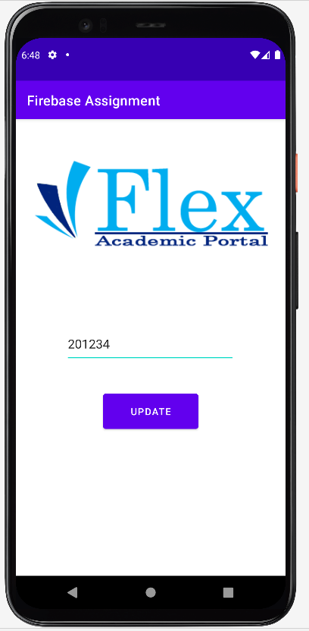

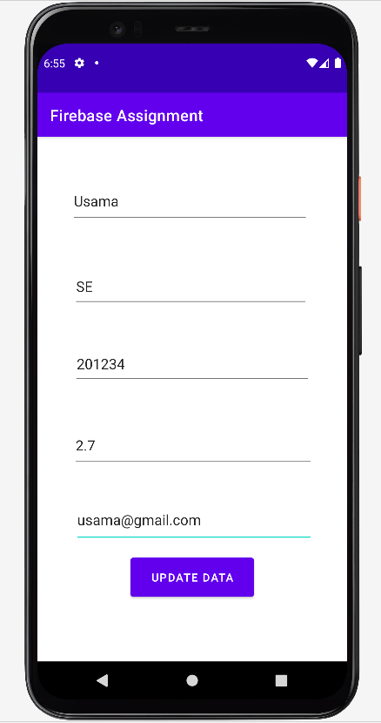

**Reports**

# **XML Code**

*<?*xml version="1.0" encoding="utf-8"*?>*<androidx.constraintlayout.widget.ConstraintLayout xmlns:android="http://schemas.android.com/apk/res/android"  
 xmlns:app="http://schemas.android.com/apk/res-auto"  
 xmlns:tools="http://schemas.android.com/tools"  
 android:layout_width="match_parent"  
 android:layout_height="match_parent">  
  
  
 <LinearLayout  
 android:id="@+id/linearLayout"  
 android:layout_width="match_parent"  
 android:layout_height="wrap_content"  
 android:orientation="horizontal"  
 app:layout_constraintEnd_toEndOf="parent"  
 app:layout_constraintStart_toStartOf="parent"  
 app:layout_constraintTop_toTopOf="parent">  
  
 <TextView  
 android:id="@+id/txtreportname"  
 android:layout_width="wrap_content"  
 android:layout_height="wrap_content"  
 android:layout_weight="1"  
 android:text="@string/txtreportname"  
 android:textColor="@color/teal_700"  
 android:textSize="20dp"  
 android:textStyle="bold"  
 tools:ignore="SpUsage,TextSizeCheck" />  
  
  
 <TextView  
 android:id="@+id/txtreportdept"  
 android:layout_width="wrap_content"  
 android:layout_height="wrap_content"  
 android:layout_weight="1"  
 android:text="@string/dept"  
 android:textColor="@color/teal_700"  
 android:textSize="20sp"  
 android:textStyle="bold"  
 tools:ignore="TextSizeCheck" />  
  
  
 <TextView  
 android:id="@+id/txtreportregno"  
 android:layout_width="wrap_content"  
 android:layout_height="wrap_content"  
 android:layout_weight="1"  
 android:text="@string/reg_no"  
 android:textColor="@color/teal_700"  
 android:textSize="20sp"  
 android:textStyle="bold"  
 tools:ignore="TextSizeCheck" />  
  
 <TextView  
 android:id="@+id/txtreportcgpa"  
 android:layout_width="wrap_content"  
 android:layout_height="wrap_content"  
 android:layout_weight="1"  
 android:text="@string/cgpa"  
 android:textColor="@color/teal_700"  
 android:textSize="20sp"  
 android:textStyle="bold"  
 tools:ignore="TextSizeCheck" />  
  
 <TextView  
 android:id="@+id/txtreportemail"  
 android:layout_width="wrap_content"  
 android:layout_height="wrap_content"  
 android:layout_weight="1"  
 android:text="@string/email"  
 android:textColor="@color/teal_700"  
 android:textSize="20sp"  
 android:textStyle="bold"  
 tools:ignore="TextSizeCheck" />  
  
  
 </LinearLayout>  
  
 <androidx.recyclerview.widget.RecyclerView  
 android:id="@+id/fbrecyclerview"  
 android:layout_width="408dp"  
 android:layout_height="368dp"  
 android:layout_marginTop="28dp"  
 android:layout_weight="1"  
  
 app:layout_constraintBottom_toBottomOf="parent"  
 app:layout_constraintEnd_toEndOf="parent"  
 app:layout_constraintHorizontal_bias="0.0"  
 app:layout_constraintStart_toStartOf="parent"  
 app:layout_constraintTop_toBottomOf="@+id/linearLayout"  
 app:layout_constraintVertical_bias="0.0" />  
  
 <Button  
 android:id="@+id/txtcgpa3plus"  
 android:layout_width="135dp"  
 android:layout_height="48dp"  
 android:layout_marginTop="20dp"  
 android:onClick="threeCgpaReport"  
 android:text="@string/txt3pluscgpa"  
 app:layout_constraintEnd_toEndOf="parent"  
 app:layout_constraintHorizontal_bias="0.434"  
 app:layout_constraintStart_toStartOf="parent"  
 app:layout_constraintTop_toBottomOf="@+id/fbrecyclerview" />  
  
 <Button  
 android:id="@+id/txtcgpa2less"  
 android:layout_width="135dp"  
 android:layout_height="48dp"  
 android:layout_marginTop="48dp"  
 android:onClick="lessTwoCgpaReport"  
 android:text="@string/txt2lesscgpa"  
 app:layout_constraintEnd_toEndOf="parent"  
 app:layout_constraintHorizontal_bias="0.434"  
 app:layout_constraintStart_toStartOf="parent"  
 app:layout_constraintTop_toTopOf="@+id/txtcgpa3plus"  
 tools:ignore="TextSizeCheck" />  
  
  
  
 <Button  
 android:id="@+id/txtsedept"  
 android:layout_width="135dp"  
 android:layout_height="48dp"  
 android:layout_marginTop="56dp"  
 android:onClick="seDeptReport"  
 android:text="@string/se_dept"  
 app:layout_constraintEnd_toEndOf="parent"  
 app:layout_constraintHorizontal_bias="0.434"  
 app:layout_constraintStart_toStartOf="parent"  
 app:layout_constraintTop_toBottomOf="@+id/txtcgpa3plus"  
 tools:ignore="OnClick" />  
  
 <Button  
 android:id="@+id/txtcsdept"  
 android:layout_width="135dp"  
 android:layout_height="48dp"  
 android:layout_marginTop="64dp"  
 android:onClick="csDeptReport"  
 android:text="@string/cs_dept"  
 app:layout_constraintBottom_toBottomOf="parent"  
 app:layout_constraintEnd_toEndOf="parent"  
 app:layout_constraintHorizontal_bias="0.434"  
 app:layout_constraintStart_toStartOf="parent"  
 app:layout_constraintTop_toBottomOf="@+id/txtcgpa2less"  
 app:layout_constraintVertical_bias="0.0"  
 tools:ignore="VisualLintBounds" />  
  
  
</androidx.constraintlayout.widget.ConstraintLayout>

# **Java Code**

package com.example.firebaseassignment;  
  
import ndroid.annotation.NonNull;  
import ndroid.appcompat.app.AppCompatActivity;  
import ndroid.recyclerview.widget.LinearLayoutManager;  
import ndroid.recyclerview.widget.RecyclerView;  
  
import android.os.Bundle;  
import android.view.View;  
import android.widget.Toast;  
  
import com.google.firebase.database.DataSnapshot;  
import com.google.firebase.database.DatabaseError;  
import com.google.firebase.database.FirebaseDatabase;  
import com.google.firebase.database.Query;  
import com.google.firebase.database.ValueEventListener;  
  
import java.util.ArrayList;  
  
public class DisplayReports extends AppCompatActivity {  
  
 ArrayList<StudentRecords> studentRecords;  
 RecyclerView recyclerView;  
 FirebaseAdapter firebaseAdapter;  
 @Override  
 protected void onCreate(Bundle savedInstanceState) {  
 super.onCreate(savedInstanceState);  
 setContentView(R.layout.*activity_display_reports*);  
 }  
  
 public void threeCgpaReport(View view)  
 {  
 studentRecords = new ArrayList<>();  
 recyclerView = findViewById(R.id.*fbrecyclerview*);  
 LinearLayoutManager linearLayoutManager = new LinearLayoutManager(this);  
 recyclerView.setLayoutManager(linearLayoutManager);  
 Query query = FirebaseDatabase.*getInstance*(“https://fir-assignment-10086-default-rtdb.firebaseio.com/”)  
 .getReference(“StudentRecord”).orderByChild(“CGPA”).startAt(“3.0”);  
 query.addValueEventListener(new ValueEventListener() {  
 @Override  
 public void onDataChange(@NonNull DataSnapshot dataSnapshot) {  
 if (dataSnapshot.exists())  
 {  
 for (DataSnapshot snapshot : dataSnapshot.getChildren())  
 {  
 StudentRecords records = new StudentRecords();  
 records.setName(snapshot.child(“Name”).getValue().toString());  
 records.setDept(snapshot.child(“Dept”).getValue().toString());  
 records.setReg_no(snapshot.child(“Reg No”).getValue().toString());  
 records.setCgpa(snapshot.child(“CGPA”).getValue().toString());  
 records.setEmail(snapshot.child(“Email”).getValue().toString());  
 studentRecords.add(records);  
 }  
 firebaseAdapter = new FirebaseAdapter(studentRecords, getApplicationContext());  
 recyclerView.setAdapter(firebaseAdapter);  
 firebaseAdapter.notifyDataSetChanged();  
 }  
 else  
 {  
 Toast.*makeText*(DisplayReports.this, “No student found with 3 or greater CGPA”, Toast.*LENGTH_SHORT*).show();  
 }  
 }  
  
 @Override  
 public void onCancelled(@NonNull DatabaseError error) {  
  
 }  
 });  
 }  
  
 public void lessTwoCgpaReport(View view) {  
 studentRecords = new ArrayList<>();  
 recyclerView = findViewById(R.id.*fbrecyclerview*);  
 LinearLayoutManager linearLayoutManager = new LinearLayoutManager(this);  
 recyclerView.setLayoutManager(linearLayoutManager);  
 Query query = FirebaseDatabase.*getInstance*(“https://fir-assignment-10086-default-rtdb.firebaseio.com/”)  
 .getReference(“StudentRecord”).orderByChild(“CGPA”).endAt(“1.99”);  
 query.addValueEventListener(new ValueEventListener() {  
 @Override  
 public void onDataChange(@NonNull DataSnapshot dataSnapshot) {  
 if (dataSnapshot.exists())  
 {  
 for (DataSnapshot snapshot : dataSnapshot.getChildren())  
 {  
 StudentRecords records = new StudentRecords();  
 records.setName(snapshot.child(“Name”).getValue().toString());  
 records.setDept(snapshot.child(“Dept”).getValue().toString());  
 records.setReg_no(snapshot.child(“Reg No”).getValue().toString());  
 records.setCgpa(snapshot.child(“CGPA”).getValue().toString());  
 records.setEmail(snapshot.child(“Email”).getValue().toString());  
 studentRecords.add(records);  
 }  
 firebaseAdapter = new FirebaseAdapter(studentRecords, getApplicationContext());  
 recyclerView.setAdapter(firebaseAdapter);  
 firebaseAdapter.notifyDataSetChanged();  
 }  
 else  
 {  
 Toast.*makeText*(DisplayReports.this, “No student found with less than 1.99 CGPA”, Toast.*LENGTH_SHORT*).show();  
 }  
 }  
  
 @Override  
 public void onCancelled(@NonNull DatabaseError error) {  
  
 }  
 });  
 }  
  
 public void seDeptReport(View view) {  
 studentRecords = new ArrayList<>();  
 recyclerView = findViewById(R.id.*fbrecyclerview*);  
 LinearLayoutManager linearLayoutManager = new LinearLayoutManager(this);  
 recyclerView.setLayoutManager(linearLayoutManager);  
 Query query = FirebaseDatabase.*getInstance*(“https://fir-assignment-10086-default-rtdb.firebaseio.com/”)  
 .getReference(“StudentRecord”).orderByChild(“Dept”).equalTo(“SE”);  
 query.addValueEventListener(new ValueEventListener() {  
 @Override  
 public void onDataChange(@NonNull DataSnapshot dataSnapshot) {  
 if (dataSnapshot.exists())  
 {  
 for (DataSnapshot snapshot : dataSnapshot.getChildren())  
 {  
 StudentRecords records = new StudentRecords();  
 records.setName(snapshot.child(“Name”).getValue().toString());  
 records.setDept(snapshot.child(“Dept”).getValue().toString());  
 records.setReg_no(snapshot.child(“Reg No”).getValue().toString());  
 records.setCgpa(snapshot.child(“CGPA”).getValue().toString());  
 records.setEmail(snapshot.child(“Email”).getValue().toString());  
 studentRecords.add(records);  
 }  
 firebaseAdapter = new FirebaseAdapter(studentRecords, getApplicationContext());  
 recyclerView.setAdapter(firebaseAdapter);  
 firebaseAdapter.notifyDataSetChanged();  
 }  
 else  
 {  
 Toast.*makeText*(DisplayReports.this, “No student of SE Dept found”, Toast.*LENGTH_SHORT*).show();  
 }  
 }  
  
 @Override  
 public void onCancelled(@NonNull DatabaseError error) {  
  
 }  
 });  
 }  
  
  
 public void csDeptReport(View view) {  
 studentRecords = new ArrayList<>();  
 recyclerView = findViewById(R.id.*fbrecyclerview*);  
 LinearLayoutManager linearLayoutManager = new LinearLayoutManager(this);  
 recyclerView.setLayoutManager(linearLayoutManager);  
 Query query = FirebaseDatabase.*getInstance*(“https://fir-assignment-10086-default-rtdb.firebaseio.com/”)  
 .getReference(“StudentRecord”).orderByChild(“Dept”).equalTo(“CS”);  
 query.addValueEventListener(new ValueEventListener() {  
 @Override  
 public void onDataChange(@NonNull DataSnapshot dataSnapshot) {  
 if (dataSnapshot.exists())  
 {  
 for (DataSnapshot snapshot : dataSnapshot.getChildren())  
 {  
 StudentRecords records = new StudentRecords();  
 records.setName(snapshot.child(“Name”).getValue().toString());  
 records.setDept(snapshot.child(“Dept”).getValue().toString());  
 records.setReg_no(snapshot.child(“Reg No”).getValue().toString());  
 records.setCgpa(snapshot.child(“CGPA”).getValue().toString());  
 records.setEmail(snapshot.child(“Email”).getValue().toString());  
 studentRecords.add(records);  
 }  
 firebaseAdapter = new FirebaseAdapter(studentRecords, getApplicationContext());  
 recyclerView.setAdapter(firebaseAdapter);  
 firebaseAdapter.notifyDataSetChanged();  
 }  
 else  
 {  
 Toast.*makeText*(DisplayReports.this, “No student of SE Dept found”, Toast.*LENGTH_SHORT*).show();  
 }  
 }  
  
 @Override  
 public void onCancelled(@NonNull DatabaseError error) {  
  
 }  
 });  
 }  
}

# **Outputs**

**Other Java Classes**

# **FirebaseAdapater.java**

package com.example.firebaseassignment;  
  
import android.content.Context;  
import android.view.LayoutInflater;  
import android.view.View;  
import android.view.ViewGroup;  
import android.widget.ImageView;  
import android.widget.TextView;  
  
import androidx.annotation.NonNull;  
import androidx.recyclerview.widget.RecyclerView;  
  
import java.util.ArrayList;  
  
public class FirebaseAdapter extends RecyclerView.Adapter<FirebaseAdapter.ViewHolder> {  
  
 ArrayList<StudentRecords> studentRecordsArrayList;  
 Context context;  
  
 public FirebaseAdapter(ArrayList<StudentRecords> studentRecordsArrayList, Context context) {  
 this.studentRecordsArrayList = studentRecordsArrayList;  
 this.context = context;  
 }  
  
 @NonNull  
 @Override  
 public ViewHolder onCreateViewHolder(@NonNull ViewGroup parent, int viewType) {  
 View view = LayoutInflater.*from*(parent.getContext())  
 .inflate(R.layout.*reports*,parent, false);  
 return new ViewHolder(view);  
 }  
  
  
  
 @Override  
 public void onBindViewHolder(@NonNull ViewHolder holder, int position) {  
 holder.Name.setText(studentRecordsArrayList.get(position).getName());  
 holder.Dept.setText(studentRecordsArrayList.get(position).getDept());  
 holder.Reg_no.setText(studentRecordsArrayList.get(position).getReg_no());  
 holder.Cgpa.setText(studentRecordsArrayList.get(position).getCgpa());  
 holder.Email.setText(studentRecordsArrayList.get(position).getEmail());  
  
 System.*out*.println(studentRecordsArrayList.get(position).getName());  
  
 }  
  
 @Override  
 public int getItemCount() {  
 return studentRecordsArrayList.size();  
 }  
  
 public class ViewHolder extends RecyclerView.ViewHolder{  
  
 TextView Name, Dept, Reg_no, Cgpa, Email;  
 ImageView imageView;  
 public ViewHolder(@NonNull View view) {  
 super(view);  
 Name = view.findViewById(R.id.*txtname*);  
 Dept = view.findViewById(R.id.*txtdept*);  
 Reg_no = view.findViewById(R.id.*txtregno*);  
 Cgpa = view.findViewById(R.id.*txtcgpa*);  
 Email = view.findViewById(R.id.*txtemail*);  
 }  
 }  
}

# **StudentRecords.java**

package com.example.firebaseassignment;  
  
public class StudentRecords {  
 String Name, Dept, Reg_no, Cgpa, Email;  
  
 public StudentRecords(String name, String dept, String reg_no, String cgpa, String email) {  
 Name = name;  
 Dept = dept;  
 Reg_no = reg_no;  
 Cgpa = cgpa;  
 Email = email;  
 }  
  
 public StudentRecords() {  
   
 }  
  
 public String getName() {  
 return Name;  
 }  
  
 public void setName(String name) {  
 Name = name;  
 }  
  
 public String getDept() {  
 return Dept;  
 }  
  
 public void setDept(String dept) {  
 Dept = dept;  
 }  
  
 public String getReg_no() {  
 return Reg_no;  
 }  
  
 public void setReg_no(String reg_no) {  
 Reg_no = reg_no;  
 }  
  
 public String getCgpa() {  
 return Cgpa;  
 }  
  
 public void setCgpa(String cgpa) {  
 Cgpa = cgpa;  
 }  
  
 public String getEmail() {  
 return Email;  
 }  
  
 public void setEmail(String email) {  
 Email = email;  
 }  
}